Table S1 List of accessions, their growth habits, type, origin and DSIs
Accession name | Habit | Type | Origin | Disease severity index (DSI)
 |  |  |  | 5X- L-G02 |  | 2B |  | 3A |  | 3D
Ames1669 | Spring | oilseed rape | North America | 42 | . |  | . |  | .
Ames20126 | Spring | oilseed rape | North America | 100 | . |  | 11.1 |  | .
Ames6074 | Spring | oilseed rape | North America | 26 | . |  | . |  | .
Ames6075 | Spring | oilseed rape | North America | 28 | . |  | . |  | .
Ames6076 | Spring | oilseed rape | North America | 38 | . |  | . |  | .
CGN06820 | Winter | oilseed rape | Europe | 94 | 100 |  | 86.7 |  | 40
CGN06821 | Winter | oilseed rape | Europe | 94 | 100 |  | 100 |  | 72.2
CGN06822 | Winter | oilseed rape | Europe | 0 | 0 |  | 5.6 |  | 5.6
CGN06868 | Winter | oilseed rape | Europe | 75 | 100 |  | 100 |  | 50
CGN06869 | Winter | oilseed rape | Europe | 97 | 100 |  | 33.3 |  | 50
CGN06870 | Winter | oilseed rape | Europe | 97 | 33.3 |  | 50 |  | 40
CGN06873 | Winter | oilseed rape | Europe | 97 | 100 |  | 100 |  | 66.7
CGN06875 | Winter | oilseed rape | Europe | 100 | 100 |  | 100 |  | 100
CGN06876 | Winter | oilseed rape | Europe | 97 | 100 |  | 100 |  | 41.7
CGN06879 | Winter | oilseed rape | Europe | 100 | 100 |  | 100 |  | 91.7
CGN06883 | Winter | oilseed rape | Europe | 78 | 100 |  | 100 |  | 100
CGN06884 | Winter | oilseed rape | Europe | 14 | 100 |  | 100 |  | 100
CGN06885 | Winter | oilseed rape | Europe | 78 | 100 |  | 100 |  | 100
CGN06887 | Winter | fodder rapa | Oceania | 97 | 78 |  | 96 |  | 83
CGN06888 | Winter | fodder rapa | Europe | 92 | 33 |  | 100 |  | 100
CGN06890 | Winter | fodder rapa | Europe | 42 | 94.4 |  | 100 |  | 50
CGN06893 | Spring | oilseed rape | Europe | 94 | 100 |  | 100 |  | 100
CGN06894 | Winter | oilseed rape | Europe | 100 | 100 |  | 100 |  | 66.7
CGN06895 | Winter | oilseed rape | Europe | 97 | 100 |  | 91.7 |  | 42.9
CGN06896 | Winter | oilseed rape | Europe | 0 | 50 |  | 100 |  | 50
CGN06897 | Winter | oilseed rape | Asia | 72 | 100 |  | 95.8 |  | 85.7
CGN06898 | Winter | oilseed rape | Europe | 100 | 66.7 |  | 100 |  | 33.3
CGN06899 | Winter | Swede rape | Europe | 67 | 67 |  | 67 |  | 67
CGN06900 | Winter | Swede rape | Europe | 6 | 100 |  | 100 |  | 100
CGN06901 | Winter | Swede rape | Europe | 0 | 0 |  | 0 |  | 0
CGN06902 | Winter | Swede rape | Oceania | 97 | 100 |  | 100 |  | 100
CGN07227 | Winter | oilseed rape | Europe | 94 | 97 |  | 97 |  | 97
CGN07229 | Winter | oilseed rape | Europe | 97 | 100 |  | 100 |  | 100
CGN07230 | Winter | fodder rapa | Europe | 100 | 100 |  | 100 |  | 100
CGN07231 | Winter | fodder rapa | Europe | 97 | 10 |  | 100 |  | 100
CGN07232 | Winter | fodder rapa | Europe | 97 | 97 |  | 97 |  | 97
CGN07233 | Winter | fodder rapa | Europe | 97 | 0 |  | 16.7 |  | 0
CGN07234 | Winter | fodder rapa | Europe | 100 | 100 |  | 100 |  | 100
CGN07235 | Winter | fodder rapa | Europe | 100 | 100 |  | 100 |  | 100
CGN07236 | Spring | oilseed rape | Europe | 100 | 100 |  | 100 |  | 33.3
CGN07237 | Winter | Swede rape | Europe | 94 | 100 |  | 100 |  | 100
CGN07311 | Winter | fodder rapa | Europe | 92 | 92 |  | 92 |  | 92
CGN11016 | Winter | oilseed rape | Europe | 100 | 100 |  | 100 |  | 66.7
CGN11017 | Winter | oilseed rape | Unknown | 100 | 50 |  | 50 |  | 75
CGN12014 | Spring | oilseed rape | Europe | 100 | 94.4 |  | 96.7 |  | 90
CGN13907 | Winter | fodder rapa | Europe | 100 | 100 |  | 100 |  | 83.3
CGN13908 | Winter | fodder rapa | Europe | 94 | 100 |  | 100 |  | 91.7
CGN13910 | Winter | fodder rapa | Europe | 94 | 100 |  | 100 |  | 76.2
CGN13911 | Winter | fodder rapa | Europe | 100 | 100 |  | 100 |  | 50
CGN13912 | Winter | oilseed rape | Europe | 94 | 100 |  | 100 |  | 80.6
CGN13918 | Winter | fodder rapa | Europe | 67 | 66.7 |  | 22.2 |  | 40
CGN13920 | Winter | fodder rapa | Europe | 72 | 100 |  | 100 |  | 44.4
CGN13921 | Winter | fodder rapa | Europe | 94 | 90.9 |  | 100 |  | 63.9
CGN13923 | Winter | fodder rapa | Europe | 92 | 69.7 |  | 86.1 |  | 88.9
CGN13934 | Winter | oilseed rape | Europe | 100 | 52.8 |  | 66.7 |  | 47.2
CGN14113 | Winter | oilseed rape | Europe | 89 | 89 |  | 89 |  | 89
CGN14115 | Winter | oilseed rape | Europe | 97 | 91.7 |  | 91.7 |  | 11.1
CGN15177 | Winter | fodder rapa | Europe | 100 | 22.2 |  | 33.3 |  | 0
CGN15181 | Winter | fodder rapa | Europe | 94 | 66.7 |  | 83.3 |  | 66.7
CGN15182 | Winter | fodder rapa | Europe | 86 | 61.1 |  | 11.1 |  | 16.7
CGN17300 | Winter | oilseed rape | Europe | 94 | 100 |  | 66.7 |  | 51.5
CGN17302 | Winter | oilseed rape | Europe | 92 | 100 |  | 70.8 |  | 36.1
CGN17303 | Winter | oilseed rape | Europe | 83 | 100 |  | 100 |  | 38.9
CGN17304 | Winter | oilseed rape | Europe | 100 | 100 |  | 66.7 |  | 18.2
CGN17306 | Winter | oilseed rape | Africa | 100 | 100 |  | 100 |  | 100
CGN17308 | Winter | oilseed rape | Europe | 100 | 100 |  | 100 |  | 55.6
CGN17309 | Winter | oilseed rape | Europe | 92 | 66.7 |  | 61.1 |  | 80
CGN17310 | Winter | oilseed rape | Europe | 94 | 80 |  | 80.6 |  | 75
CGN17312 | Winter | oilseed rape | Europe | 100 | 95.8 |  | 93.9 |  | 22.2
CGN17313 | Winter | oilseed rape | Europe | 89 | 100 |  | 100 |  | 8.3
CGN17314 | Winter | oilseed rape | Europe | 94 | 100 |  | 100 |  | 33.3
CGN17316 | Winter | oilseed rape | Europe | 94 | 50 |  | 77.8 |  | 0
CGN17317 | Winter | oilseed rape | Europe | 100 | 100 |  | 100 |  | 83.3
CGN17321 | Winter | oilseed rape | Europe | 97 | 94.4 |  | 75 |  | 33.3
CGN17322 | Winter | oilseed rape | Europe | 89 | 83.3 |  | 100 |  | 33.3
CGN17323 | Winter | oilseed rape | Europe | 100 | 94.4 |  | 100 |  | 66.7
CGN17330 | Winter | oilseed rape | Europe | 94 | 100 |  | 93.3 |  | 61.1
CGN17331 | Winter | oilseed rape | Europe | 58 | 100 |  | 97 |  | 75
CGN17333 | Winter | oilseed rape | Europe | 83 | 100 |  | 100 |  | 46.7
CGN17337 | Winter | oilseed rape | Europe | 97 | 100 |  | 100 |  | 20
CGN17339 | Winter | oilseed rape | Europe | 86 | 95.2 |  | 91.7 |  | 14.8
CGN17342 | Winter | oilseed rape | Europe | 100 | 83.3 |  | 100 |  | 76.7
CGN17344 | Winter | oilseed rape | Europe | 100 | 100 |  | 95.8 |  | 33.3
CGN17347 | Winter | oilseed rape | Europe | 100 | 100 |  | 100 |  | 33.3
CGN17348 | Winter | oilseed rape | Europe | 100 | 94.4 |  | 97 |  | 36.7
CGN17352 | Winter | oilseed rape | Europe | 97 | 100 |  | 100 |  | 30.3
CGN17353 | Winter | oilseed rape | Europe | 92 | 90 |  | 91.7 |  | 66.7
CGN17358 | Winter | oilseed rape | Europe | 89 | 91.7 |  | 97.2 |  | 63.9
CGN17363 | Winter | oilseed rape | Europe | 100 | 100 |  | 100 |  | 100
CGN17364 | Winter | oilseed rape | Europe | 100 | 97.2 |  | 100 |  | 41.7
CGN17367 | Winter | oilseed rape | Europe | 97 | 96.7 |  | 100 |  | 91.7
CGN17369 | Winter | oilseed rape | Europe | 0 | 0 |  | 0 |  | 0
CGN17370 | Winter | oilseed rape | Europe | 94 | 94.4 |  | 100 |  | 33.3
CGN17371 | Winter | oilseed rape | Europe | 97 | 91.7 |  | 100 |  | 27.3
CGN17372 | Winter | oilseed rape | Europe | 81 | 100 |  | 100 |  | 27.8
CGN17373 | Winter | oilseed rape | Europe | 80 | 100 |  | 100 |  | 33.3
CGN17374 | Winter | oilseed rape | Europe | 77 | 100 |  | 100 |  | 30.6
CGN17375 | Winter | oilseed rape | Europe | 100 | 94.4 |  | 88.9 |  | 44.4
CGN17376 | Winter | oilseed rape | North America | 83 | 97.2 |  | 100 |  | 52.8
CGN17377 | Winter | oilseed rape | Europe | 12 | 69.4 |  | 77.8 |  | 15.2
CGN17379 | Winter | oilseed rape | Europe | 14 | 83.3 |  | 100 |  | 40.7
CGN17380 | Winter | oilseed rape | Europe | 25 | 91.7 |  | 97.2 |  | 47.2
CGN17381 | Winter | oilseed rape | Europe | 0 | 97.2 |  | 97.2 |  | 30.6
CGN17382 | Winter | oilseed rape | Europe | 97 | 100 |  | 93.3 |  | 50
CGN17383 | Winter | oilseed rape | Europe | 100 | 91.7 |  | 94.4 |  | 72.2
CGN18956 | Winter | oilseed rape | Europe | 97 | 100 |  | 86.1 |  | 83.3
CGN18957 | Winter | oilseed rape | Europe | 0 | 100 |  | 100 |  | 40.7
CGN18960 | Winter | oilseed rape | Europe | 100 | 97.2 |  | 100 |  | 88.9
CGN18961 | Winter | oilseed rape | Europe | 94 | 100 |  | 100 |  | 100
CGN18962 | Winter | oilseed rape | Europe | 78 | 83.3 |  | 83.3 |  | 55.6
CGN18968 | Winter | oilseed rape | Europe | 83 | 97.2 |  | 91.7 |  | 88.9
CGN18972 | Winter | oilseed rape | Europe | 89 | 94.4 |  | 100 |  | 75
CGN18973 | Winter | oilseed rape | Europe | 83 | 100 |  | 100 |  | 66.7
CGN18974 | Winter | oilseed rape | Europe | 97 | 94.4 |  | 100 |  | 69.4
CGN18977 | Winter | oilseed rape | Europe | 92 | 97.2 |  | 88.9 |  | 66.7
CGN19953 | Winter | oilseed rape | Europe | 69 | 90 |  | 100 |  | 66.7
CGN19959 | Winter | oilseed rape | Europe | 86 | 100 |  | 100 |  | 88.9
CGN19964 | Spring | oilseed rape | North America | 100 | 91.7 |  | 91.7 |  | 100
CGN19966 | Spring | oilseed rape | Asia | 97 | 100 |  | 100 |  | 85.7
CGN19967 | Spring | oilseed rape | Europe | 100 | 100 |  | 100 |  | 66.7
CN101857 | Spring | oilseed rape | Asia | 77 | 100 |  | 75 |  | 100
CN101858 | Spring | oilseed rape | Asia | 63 | 80 |  | 100 |  | 83.3
CN101859 | Spring | oilseed rape | Asia | 100 | 94.4 |  | 71.4 |  | 91.7
CN101860 | Spring | oilseed rape | Asia | 73 | 83.3 |  | 100 |  | 70.4
CN101872 | Spring | oilseed rape | South America | 44 | 100 |  | 100 |  | 91.7
CN101873 | Spring | oilseed rape | North America | 61 | 100 |  | 100 |  | 100
CN101874 | Spring | oilseed rape | North America | 71 | 100 |  | 100 |  | 100
CN101875 | Spring | oilseed rape | North America | 10 | 100 |  | 100 |  | 75
CN107671 | Spring | oilseed rape | Asia | 0 | . |  | . |  | .
CN107681 | Spring | oilseed rape | North America | 0 | 100 |  | 100 |  | 0
CN30467 | Winter | turnip | Europe | 100 | 100 |  | 88.9 |  | 63.9
CN31149 | Winter | Rutabaga | Europe | 10 | . |  | . |  | .
CN31150 | Winter | Rutabaga | Europe | 5 | . |  | . |  | .
CN31734 | Winter | oilseed rape | Europe | 100 | 100 |  | 100 |  | 100
CN35453 | Spring | oilseed rape | North America | 100 | 95.8 |  | 100 |  | 100
CN35641 | Winter | Swede rape | Europe | 60 | 97.2 |  | 88.9 |  | 44.4
CN35644 | Winter | Swede rape | Europe | 100 | 100 |  | 100 |  | 100
CN35996 | Winter | oilseed rape | Asia | 100 | 91.7 |  | 100 |  | 36.1
CN35997 | Winter | oilseed rape | Asia | 100 | 88.9 |  | 94.4 |  | 57.6
CN35998 | Winter | oilseed rape | Asia | 100 | 85.7 |  | 91.7 |  | 94.4
CN40224 | Spring | oilseed rape | Europe | 0 | . |  | . |  | .
CN43442 | Spring | oilseed rape | Asia | 100 | 97.2 |  | 86.1 |  | 75
CN43443 | Spring | oilseed rape | Asia | 100 | 100 |  | 100 |  | 100
CN43444 | Spring | oilseed rape | Asia | 100 | 91.7 |  | 93.3 |  | 69.4
CN43680 | Winter | oilseed rape | Asia | 100 | 100 |  | 83.3 |  | 45.8
CN43823 | Spring | oilseed rape | North America | 77 | 100 |  | 94.4 |  | 100
CN43824 | Spring | oilseed rape | North America | 100 | 75 |  | 100 |  | 69.7
CN45052 | Spring | oilseed rape | Asia | 86 | 100 |  | 100 |  | 91.7
CN45053 | Spring | oilseed rape | Asia | 100 | 100 |  | 100 |  | 100
CN46234 | Winter | oilseed rape | North America | 10 | . |  | . |  | .
CN46235 | Spring | oilseed rape | North America | 100 | 100 |  | 100 |  | 100
CN46333 | Spring | oilseed rape | North America | 100 | 88.9 |  | 100 |  | 100
CN46720 | Spring | oilseed rape | North America | 82 | 85.7 |  | 100 |  | 75
CN52741 | Spring | oilseed rape | North America | 100 | 100 |  | 100 |  | 100
MENDEL | Winter | oilseed rape | Europe | 0 | 44.4 |  | 30.6 |  | 27.8
Pabularia | Winter | oilseed rape | Europe | 0 | . |  | . |  | .
PI169080 | Winter | oilseed rape | Europe | 27 | 100 |  | 100 |  | 100
PI232895 | Winter | oilseed rape | Europe | 88 | 88 |  | 88 |  | 88
PI250135 | Spring | oilseed rape | Asia | 97 | 97 |  | 97 |  | 97
PI271452 | Spring | oilseed rape | Asia | 100 | 100 |  | 100 |  | 100
PI305280 | Winter | oilseed rape | Europe | 43 | 100 |  | 55.6 |  | 58.3
PI383422 | Winter | oilseed rape | Europe | 100 | 97.2 |  | 100 |  | 77.8
PI399418 | Winter | oilseed rape | Europe | 100 | 100 |  | 100 |  | 100
PI431574 | Spring | oilseed rape | North America | 100 | 100 |  | 100 |  | 100
PI432391 | Spring | oilseed rape | Asia | 100 | 100 |  | 100 |  | 100
PI432393 | Spring | oilseed rape | Asia | 100 | 0 |  | 0 |  | 0
PI432395 | Spring | oilseed rape | Asia | 100 | 100 |  | 100 |  | 87.5
PI443015 | Winter | oilseed rape | Europe | 3 | 11.1 |  | 4.2 |  | 28.6
PI469724 | Spring | oilseed rape | Asia | 100 | 100 |  | 100 |  | 100
PI469726 | Spring | oilseed rape | Asia | 100 | 100 |  | 100 |  | 100
PI469737 | Spring | oilseed rape | Asia | 100 | 100 |  | 100 |  | 100
PI469747 | Spring | oilseed rape | Asia | 100 | 100 |  | 100 |  | 100
PI469796 | Winter | oilseed rape | Europe | 100 | 100 |  | 100 |  | 100
PI469802 | Spring | oilseed rape | Asia | 100 | 100 |  | 100 |  | 100
PI469890 | Spring | oilseed rape | Asia | 0 | . |  | . |  | .
PI469917 | Spring | oilseed rape | Asia | 100 | 100 |  | 100 |  | 100
PI469951 | Spring | oilseed rape | Asia | 100 | 100 |  | 100 |  | 100

Table S2 Pearson correlation coefficient (r²) between DSIs of the four pathotypes
Pathotypes | LG02 | 2B | 3A | 3D
LG02 | - | 0.33 (0.07) | 0.29 (0.07) | 0.27 (0.07)
2B |  | - | 0.77 (0.04) | 0.41 (0.07)
3A |  |  | - | 0.49 (0.06)
3D |  |  |  | -
Table S3 Analysis of molecular variance (AMOVA) design and results
Source of variation | d.f. | Sum of Squares | Variance components | % of Variation
Among clusters | 1 | 21354.741 | 74.24922 Va | 4.76
Among sub-clusters within clusters | 4 | 29675.572 | 117.55613 Vb | 7.54
Within sub-clusters | 384 | 476093.430 | 1368.08457 Vc | 87.70
Fst= 0.21

Table S4 Distance method: Sub-Cluster Pairwise FST differences
 | SCA-I | SCA-II | SCA-III | SCB-I | SCB-II | SCB-III
SCA-I | 0
SCA-II | 0.12564 | 0
SCA-III | 0.08843 | 0.09107 | 0
SCB-I | 0.14482 | 0.20082 | 0.13051 | 0
SCB-II | 0.15512 | 0.18065 | 0.11533 | 0.03056 | 0
SCB-III | 0.08466 | 0.10874 | 0.04099 | 0.06121 | 0.04224 | 0

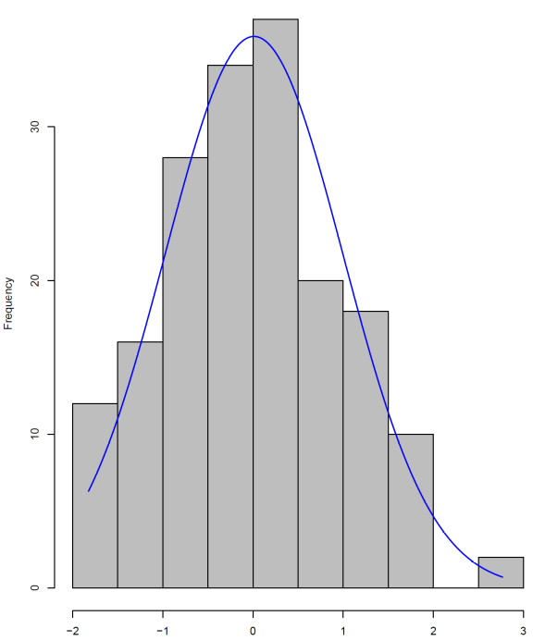
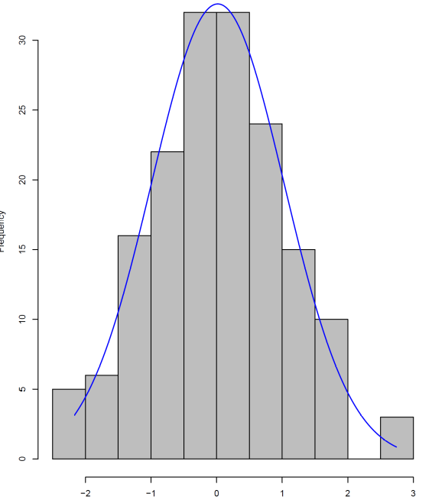
B
A

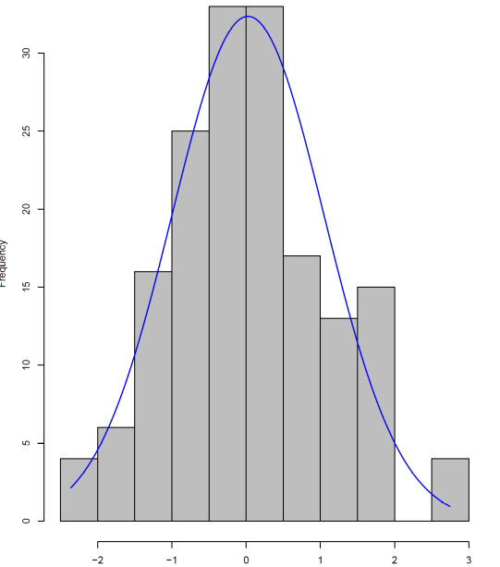
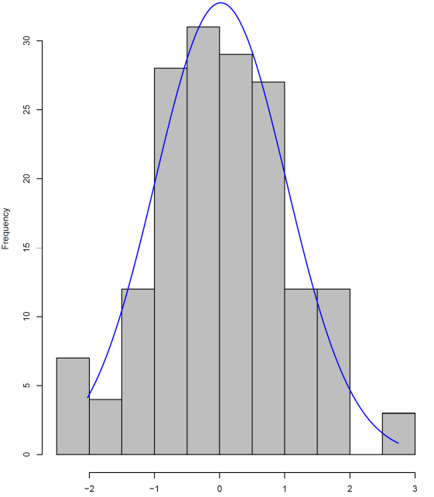
C
D

Figure S1 Frequency distribution of rank-transformed disease severity index for pathotypes (a) 5X-LG2, (b) 2B, (c) 3A, and (d) 3D.

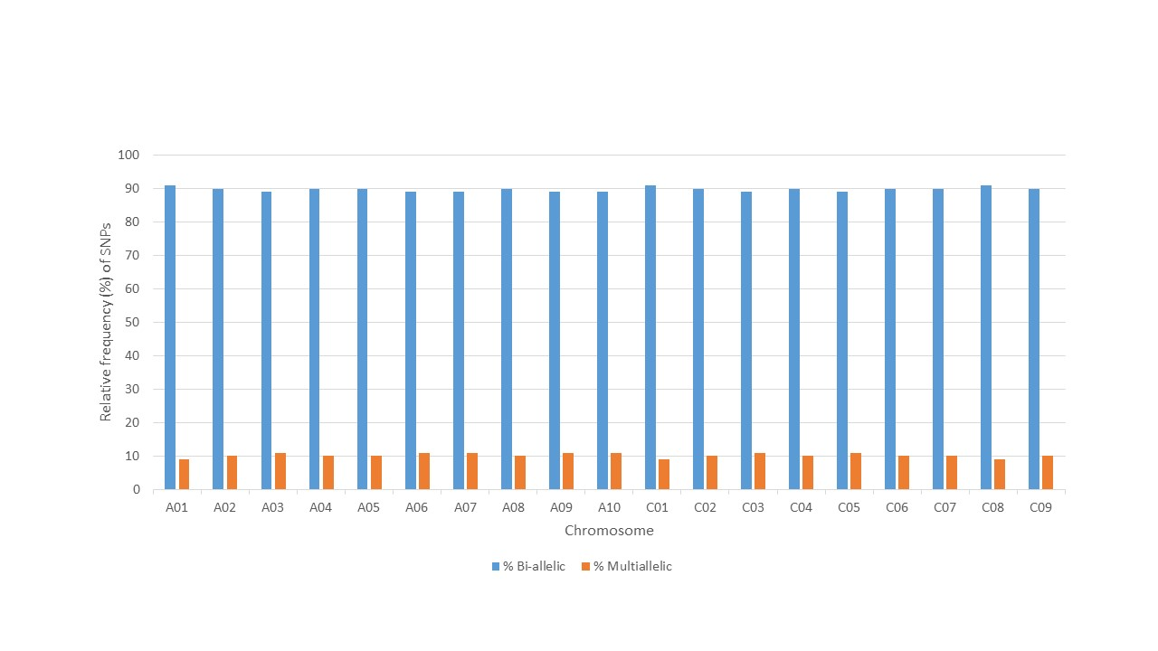
Figure S2 Relative frequency distribution (%) of Bi-/Multi-allelic SNPs

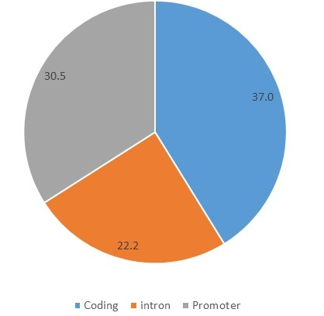
A
B

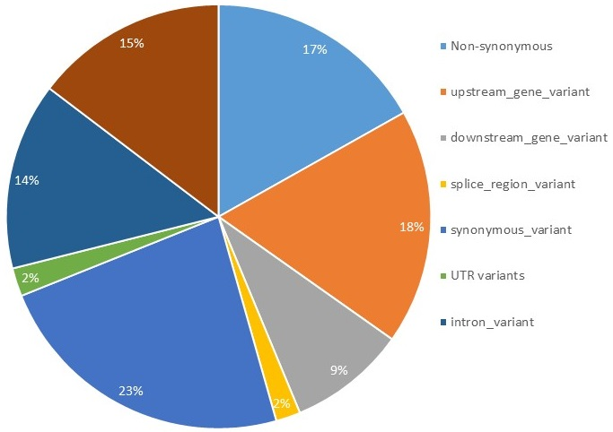
C

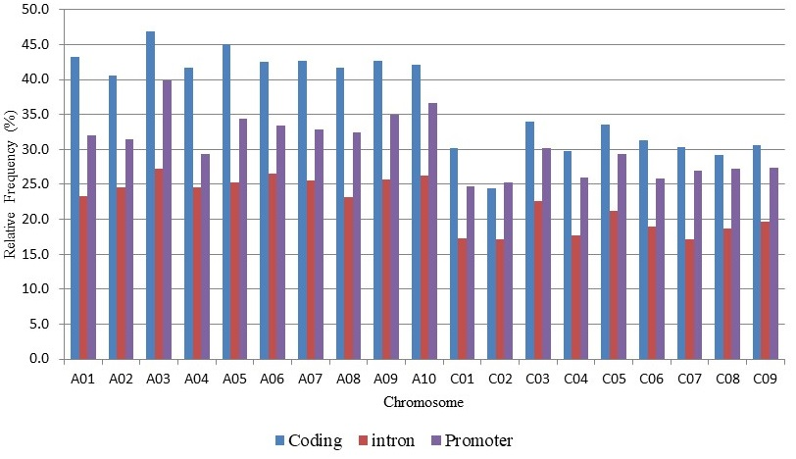
Figure S3 Variant annotation results, A. the distribution of SNPs within genic regions; coding region, introns and promotor region, B. Derailed SNP annotation based on Variant Effect Predictor software, C. Distribution of annotated SNP across B. napus chromosomes.
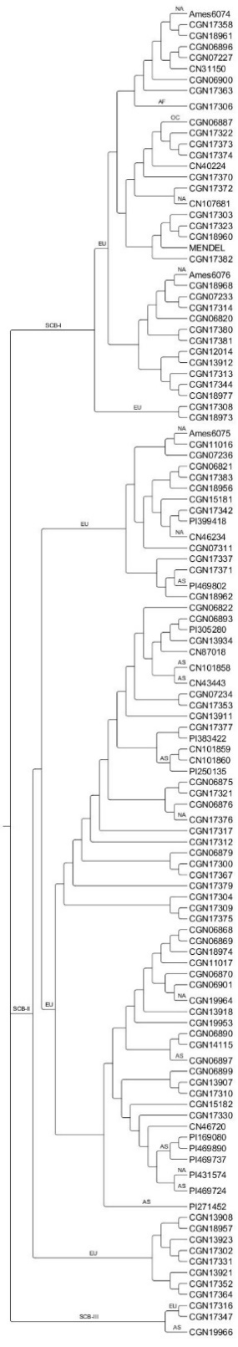
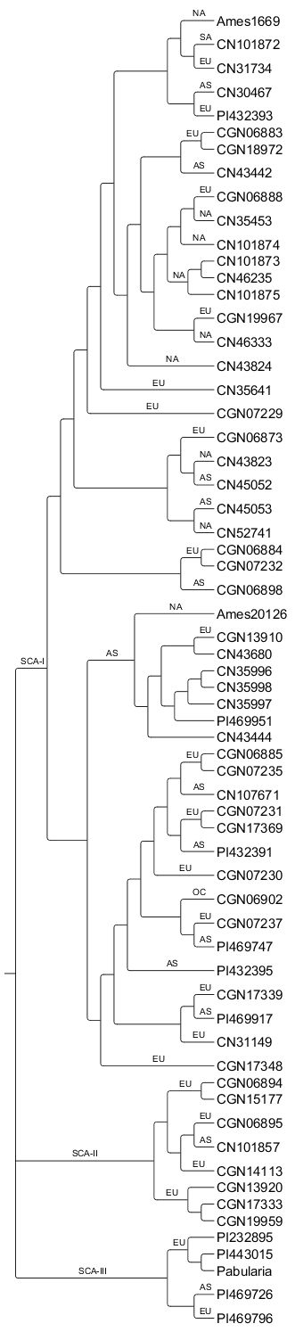
B
A

Figure S4 Phylogenetic analysis of the 177 B. napus accessions based SNP markers A. Major cluster A and subclusters SCA-I, SCA-II and SCA-III, B. Major cluster B and subcluster SCB-I, SCB-II, SCB-III. The geographical distribution at the continent level is also illustrated.

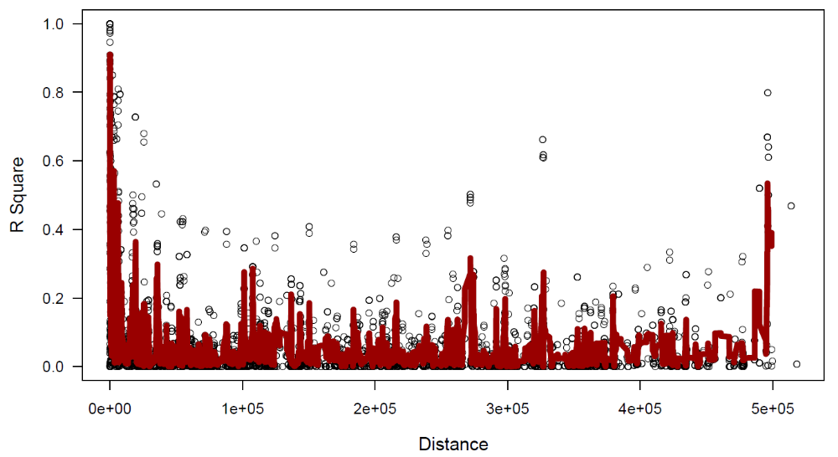
Figure S5 Genome wide linkage disequilibrium (LD) decay plot as a function of physical distance (bp). LD decay assessed in a B. napus collection of 177 accessions LD estimates are reported as squared correlations of allele frequencies (r2).

